**Slip 6: To write a1 program to get temperature notification using Arduino.**

Below is a simple Arduino program that uses a temperature sensor (like the  DHT11 or DHT22) to monitor the temperature and send notifications via the Serial  Monitor when the temperature exceeds a specified threshold.

**Components Needed:**

- Arduino (e.g., Arduino Uno)

- DHT11 or DHT22 temperature and humidity sensor

**Circuit Connections :**

1. DHT Sensor:

- Connect the VCC pin of the DHT sensor to the 5V pin on the Arduino. - Connect the GND pin of the DHT sensor to the GND pin on the Arduino. - Connect the DATA pin of the DHT sensor to a digital pin IO2 on the Arduino. 2. Add buzzer and connect one end to pin IO3 and other end to ground

3. Add a virtual terminal to the schematic capture and connect the RX of virtual  terminal to the TXD of Arduino component and TX of virtual terminal to RXD of  Arduino component.

**STEP 1: Write this code in main.py**

#include <DHT.h>

// Define the pins

#define DHTPIN 2 // Pin where the DHT11 is connected

#define BUZZER_PIN 3 // Pin where the buzzer is connected

// Initialize DHT sensor

DHT dht(DHTPIN, DHT11);

1

void setup() {

 Serial.begin(9600);

 dht.begin();

 pinMode(BUZZER_PIN, OUTPUT);

}

void loop() {

 // Wait a few seconds between measurements  delay(2000);

 // Read temperature as Celsius

 float temperature = dht.readTemperature();

 // Check if the reading failed

 if (isnan(temperature)) {

 Serial.println("Failed to read from DHT sensor!");  return;

 }

 // Print the temperature to the Serial Monitor

 Serial.print("Temperature: ");

 Serial.print(temperature);

 Serial.println(" °C");

 // Temperature threshold for notification

 if (temperature > 30) { // Change this threshold as needed  Serial.println("Temperature is high! Activating buzzer...");  digitalWrite(BUZZER_PIN, HIGH); // Activate buzzer  } else {

 digitalWrite(BUZZER_PIN, LOW); // Deactivate buzzer  }

}

2

**STEP 2:** Copy the same code in Arduino ide.

**STEP 3:** Make sure the dht library is installed.

**STEP 4:** Save the sketch and compile it.

**STEP 5:** Then, go to Sketch > Export Compiled Binary to save the compiled .hex  file.

**STEP 6:** Go to proteus and double click on the Arduino component.

**STEP 7:** Find the field for the program file or hex file, and browse to select the  .hex file you exported from the Arduino IDE.

**STEP 9:** Run the simulation.

**Explanation:**

1. Library Inclusion: The code includes the DHT library to interface with the DHT  sensor.

2. Pin Configuration: You define the pin connected to the DHT sensor and specify  its type (DHT11 or

DHT22).

3. Setup: Initializes serial communication and the DHT sensor. 4. Loop:

- Reads the temperature every 2 seconds.

- Checks if the reading is valid.

- Compares the temperature against a predefined threshold.

- Sends a notification to the Serial Monitor if the temperature exceeds the  threshold.

3 

**Connections:**

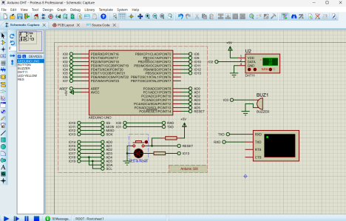4